After Creating the smart form go to the left navigation pane

Select form interface

Add num1 and num2 parameter

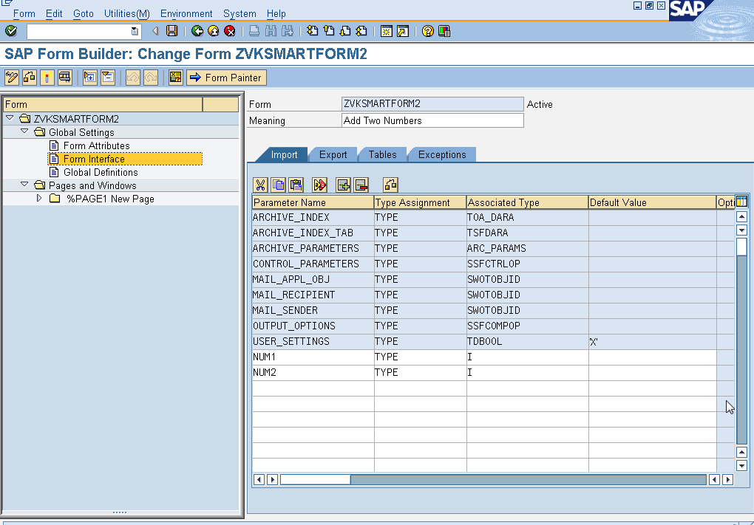

And also add result parameter in export for output

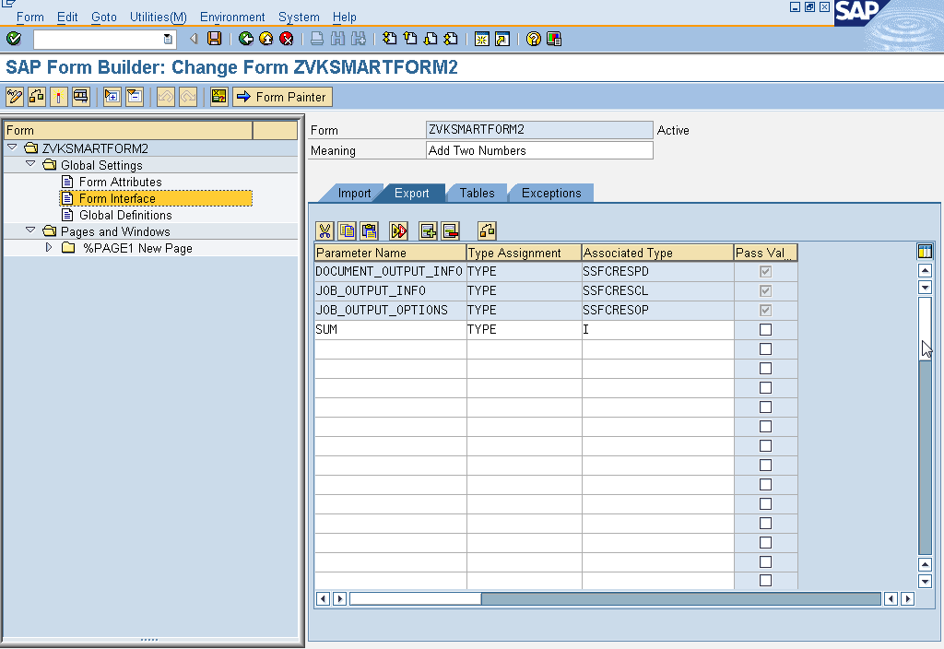

Create program line file

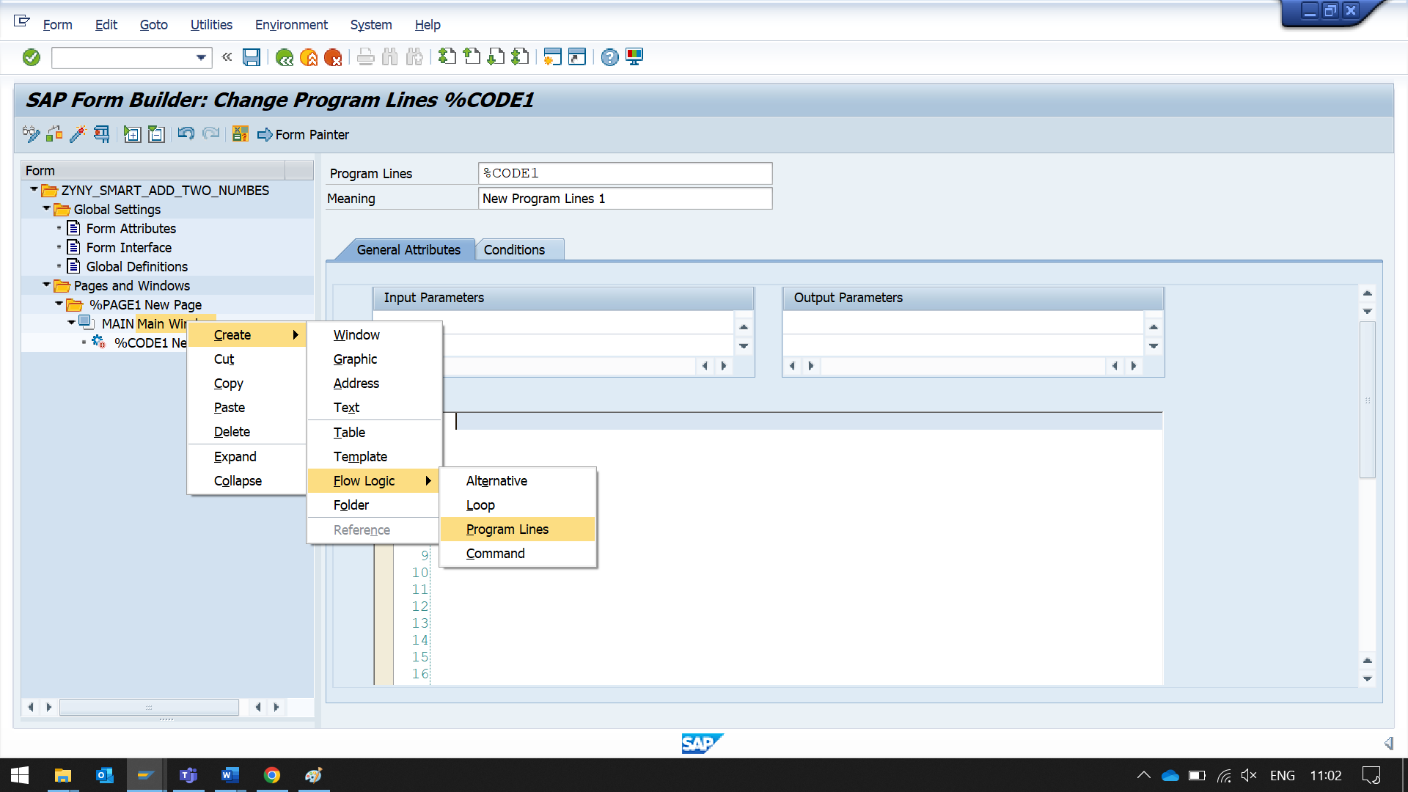

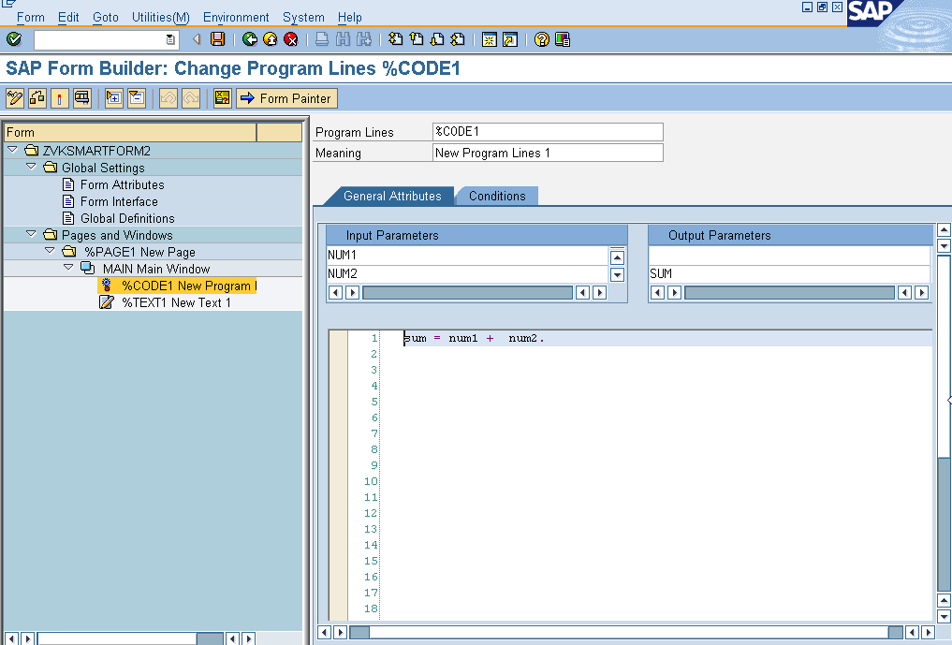

sum = num1 + num2.

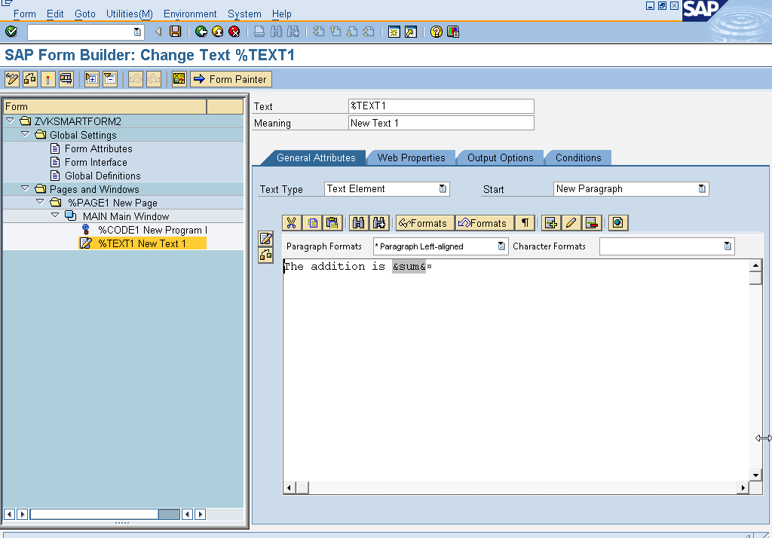

The addition is &sum&

CLICK ON THE EDITOR BUTTON

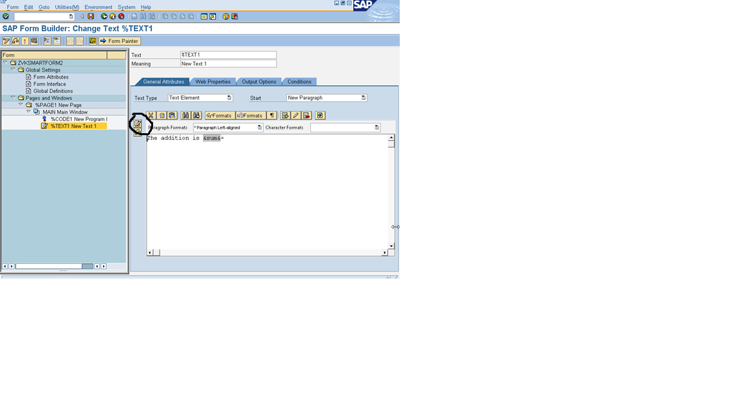

YOU WILL SEE SOME TEXT LIKE

The addition is <(>&<)>sum<(>&<)>

CHANGE IT TO

The addition is &SUM&

THEN PRESS ENTER (IMPORTANT)

GO BACK EXECUTE THE PROGRAM

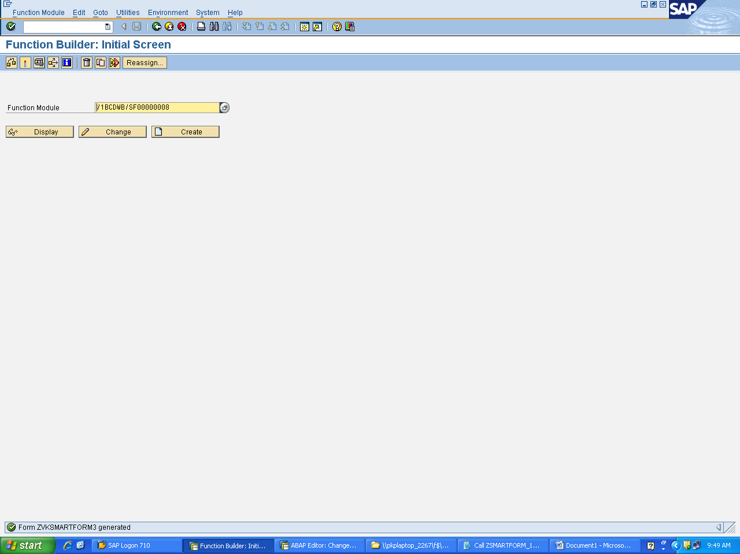

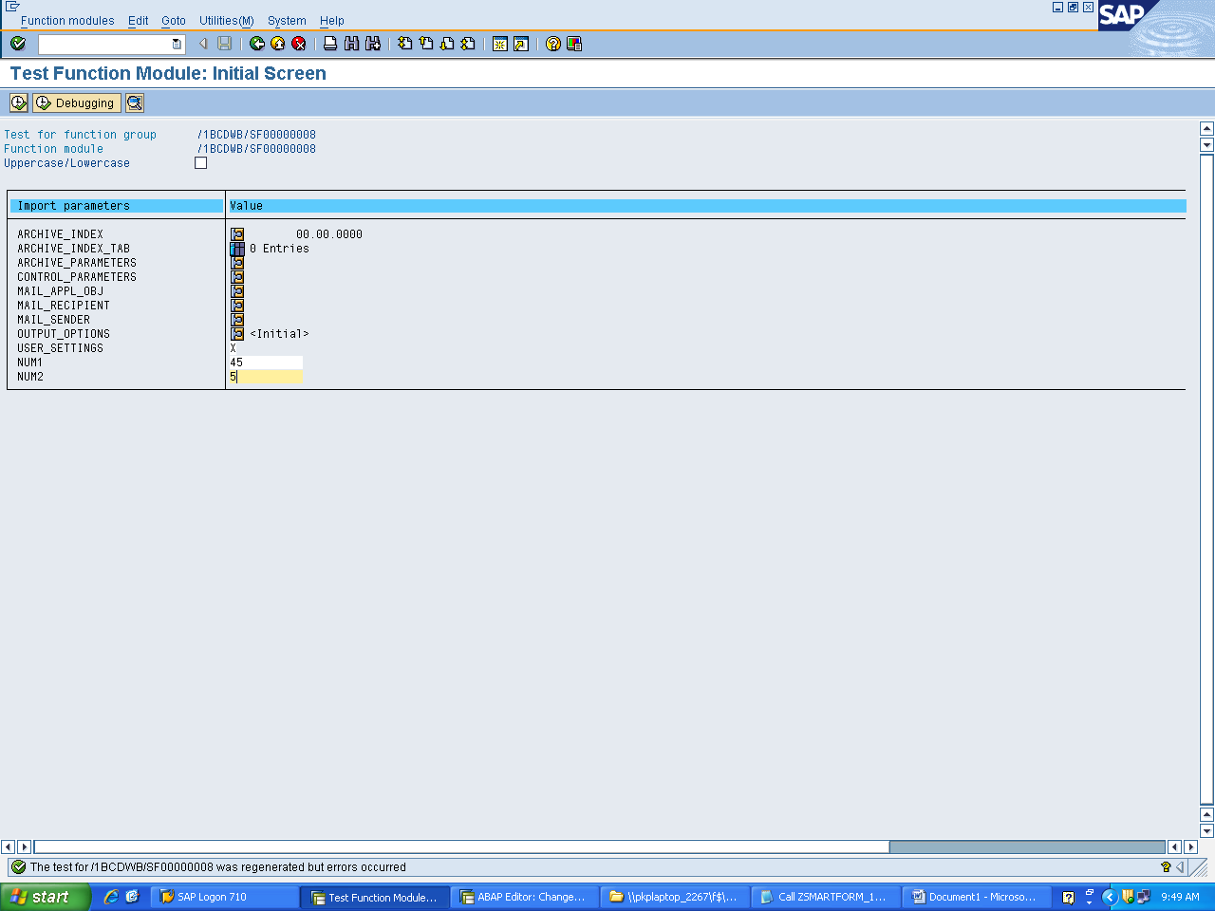

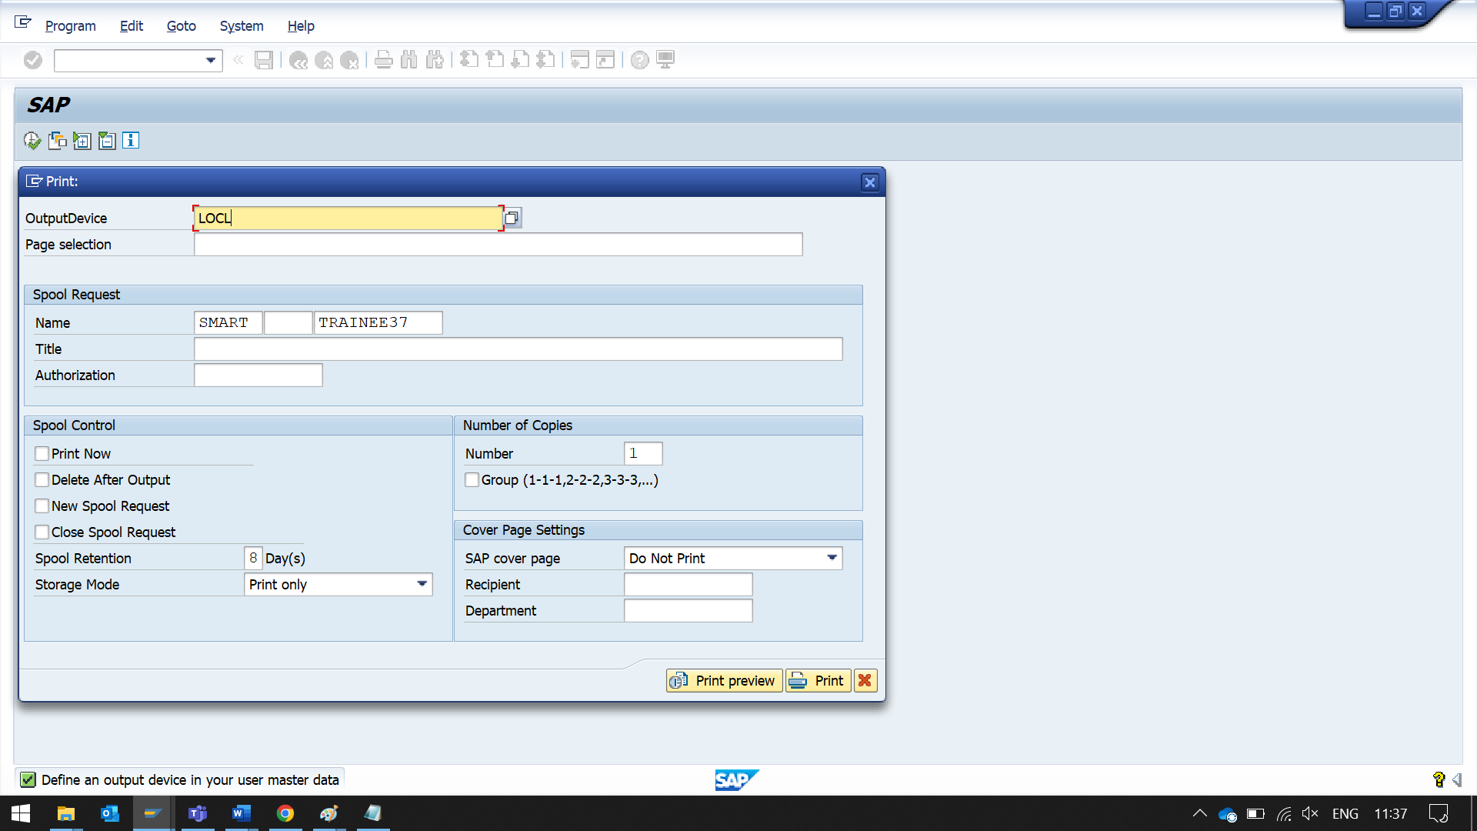

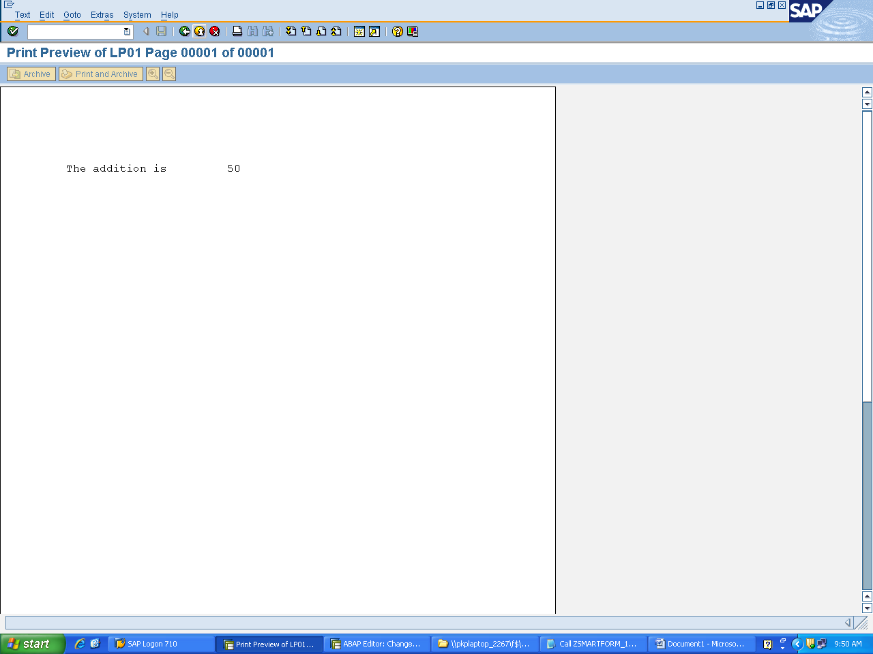

Calling the program from the editor

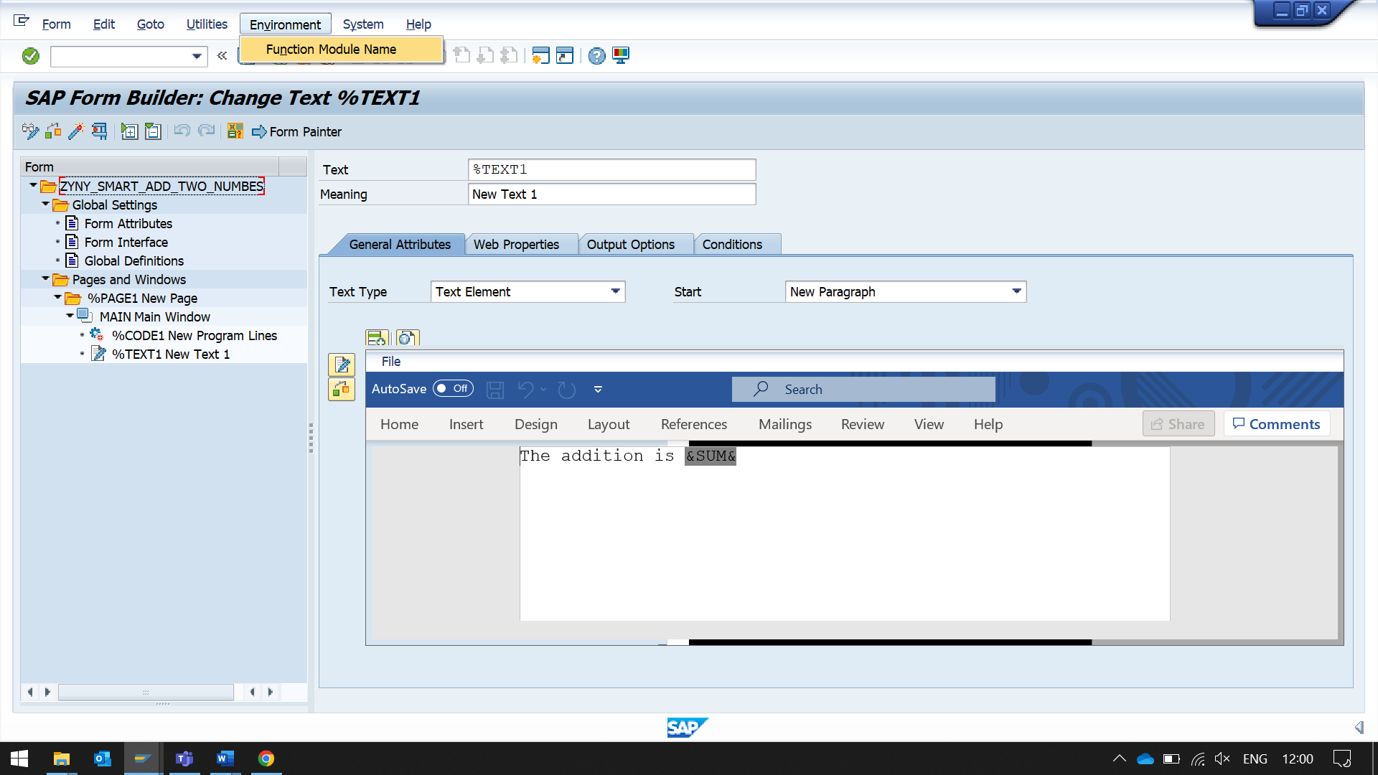

to GET FUNCTION MODULE NAME

*/1BCDWB/SF00002814

COPY THE NAME

THIS VALUE CHANGES ON DIFFRENT ENVIRONMENTS

REPORT ZNYN_SMART_FORMS_PROG.  
*/1BCDWB/SF00002814  
*FUNCTION MODULE NAME this changes, when environment change  
  
DATA : V_FMNAME TYPE RS38L_FNAM.  
"RUN TIME SMART FORM WILL COME TO THIS VARIBALR  
DATA : V_FNAME TYPE TDSFNAME.  
  
DATA : RES TYPE I.  
  
V_FNAME = 'ZYNY_SMART_ADD_TWO_NUMBES'.  
  
PARAMETERS : N1 TYPE I,  
              N2 TYPE I.  
*calling the function module  
*THIS FUNCTION MODULE GIVES THE RUNTIME FM GENERATED BY  
* SMARTFORMS  
  
CALL FUNCTION 'SSF_FUNCTION_MODULE_NAME'  
    EXPORTING  
      formname                 = V_FNAME   "formname  
   IMPORTING  
      FM_NAME                  = V_FMNAME.  
  
  IF sy-subrc <> 0.  
* MESSAGE ID SY-MSGID TYPE SY-MSGTY NUMBER SY-MSGNO  
*         WITH SY-MSGV1 SY-MSGV2 SY-MSGV3 SY-MSGV4.  
  ENDIF.  
  
CALL FUNCTION V_FMNAME "'/1BCDWB/SF00002814'  
  EXPORTING  
    NUM1                       = N1  
    NUM2                       = N2  
 IMPORTING  
   SUM                        = RES  
 EXCEPTIONS  
   OTHERS                     = 5  
          .  
IF SY-SUBRC = 0.  
* Implement suitable error handling here  
*  WRITE: ' THE RESULT IS:' , RES.  
ENDIF.

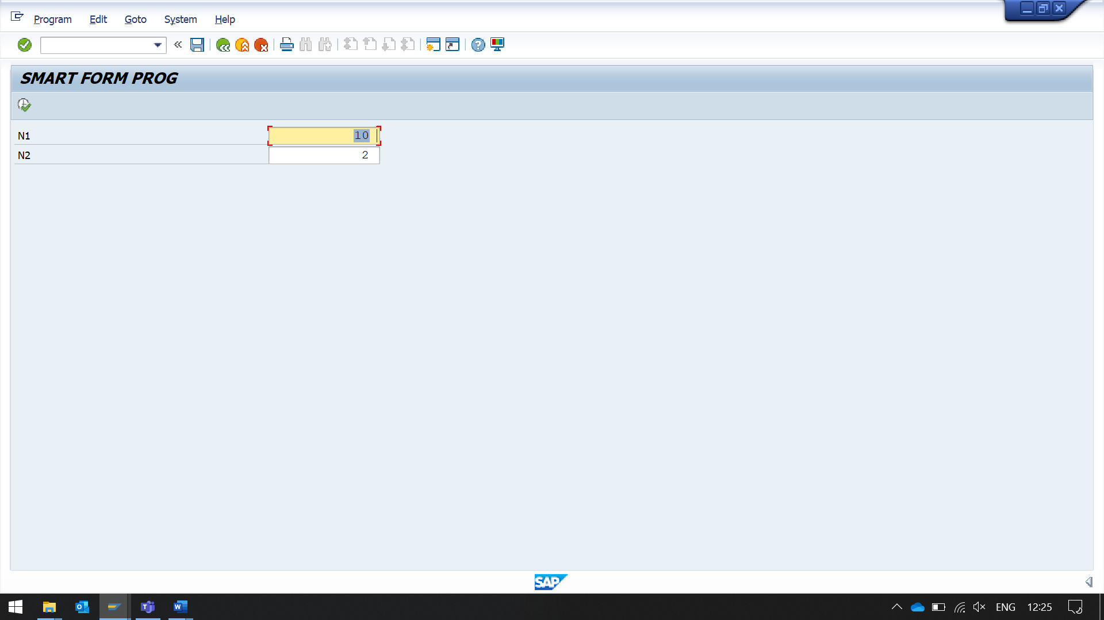

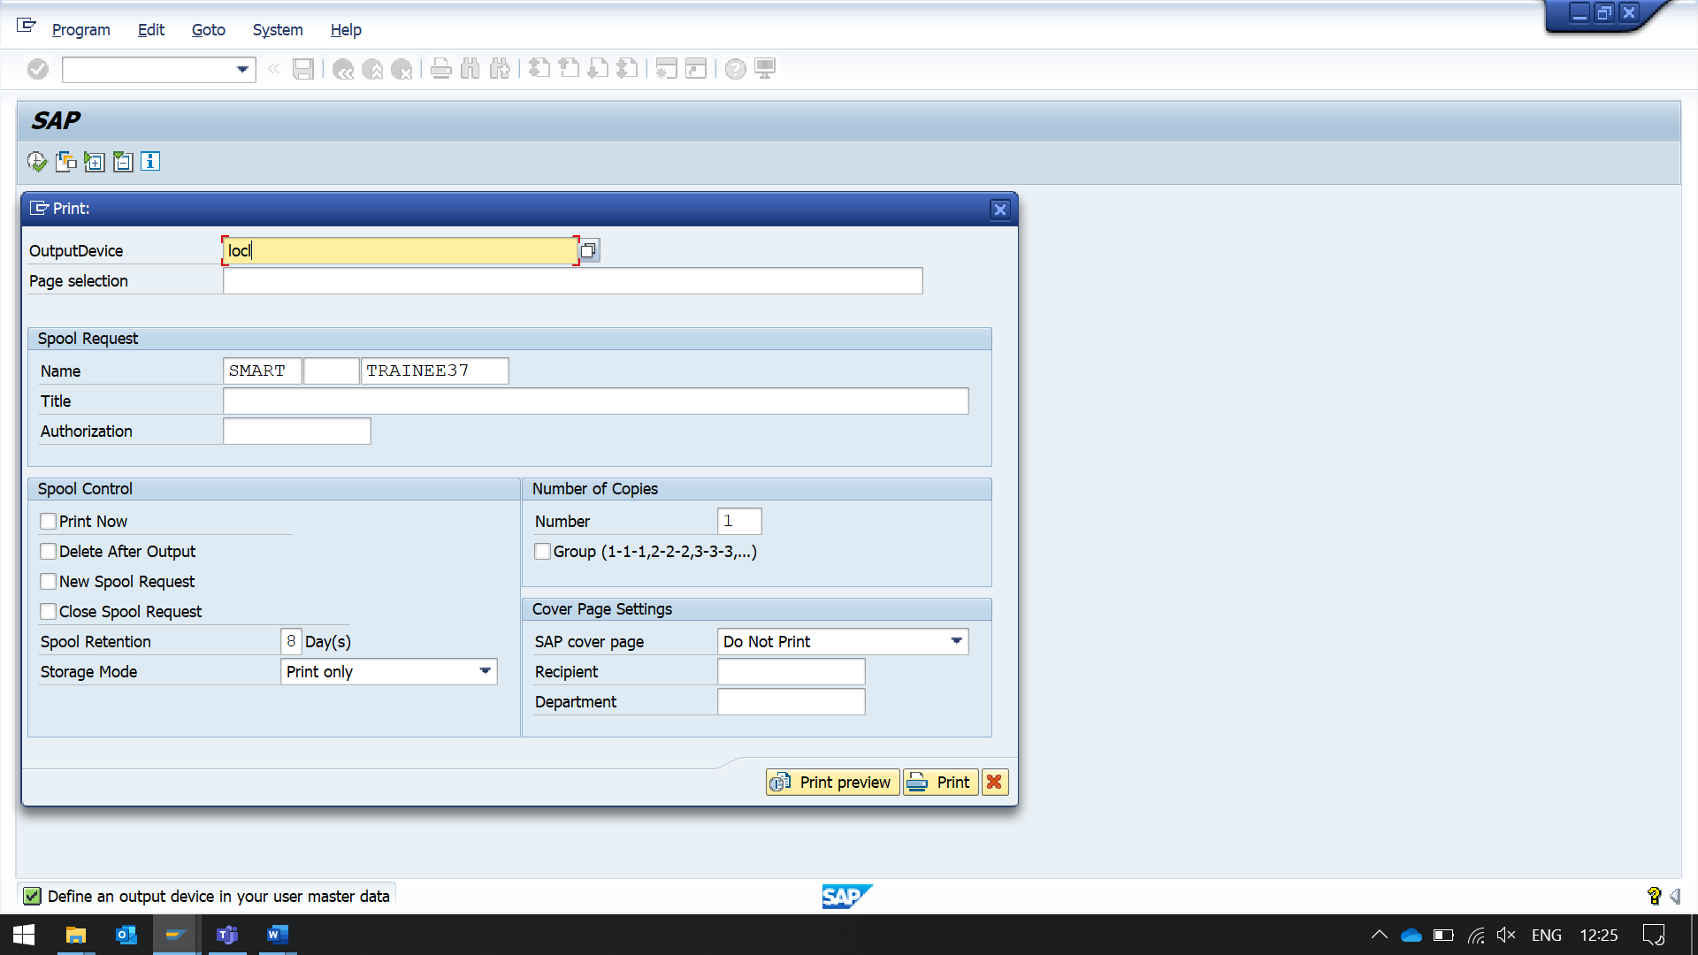 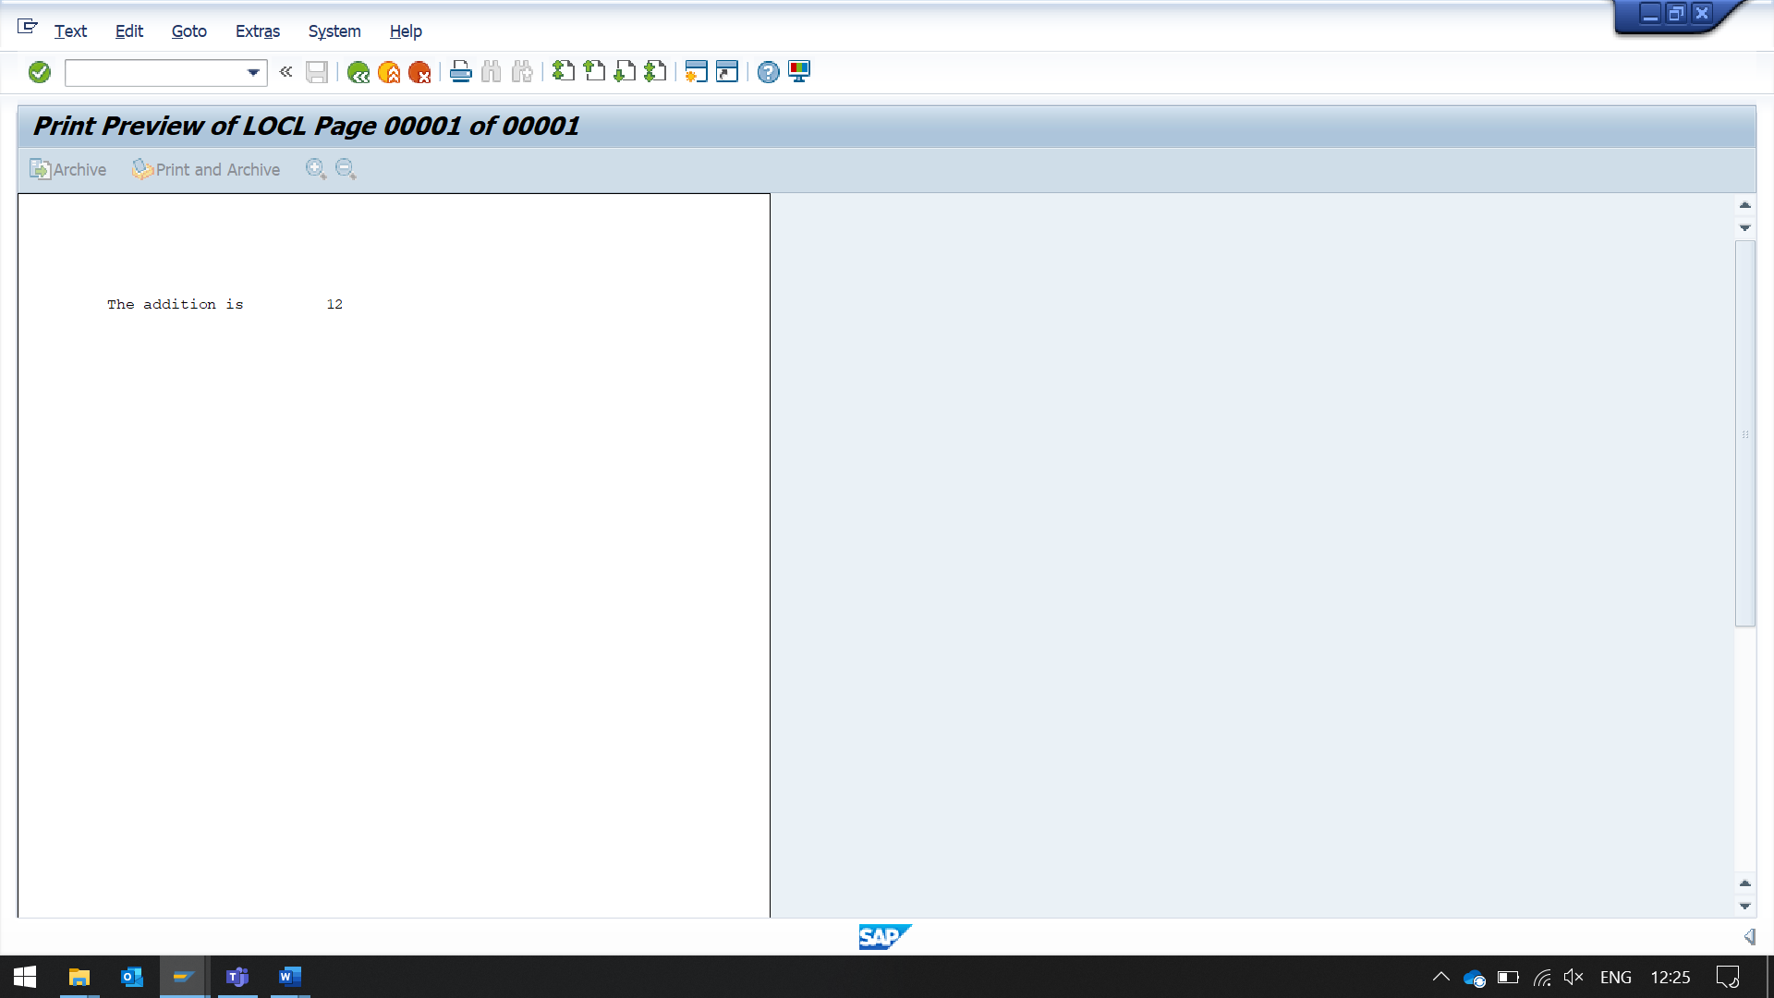

IN THE ABOVE CASE SUM IS DECLARED AS AN EXPORTING PARAMETER.

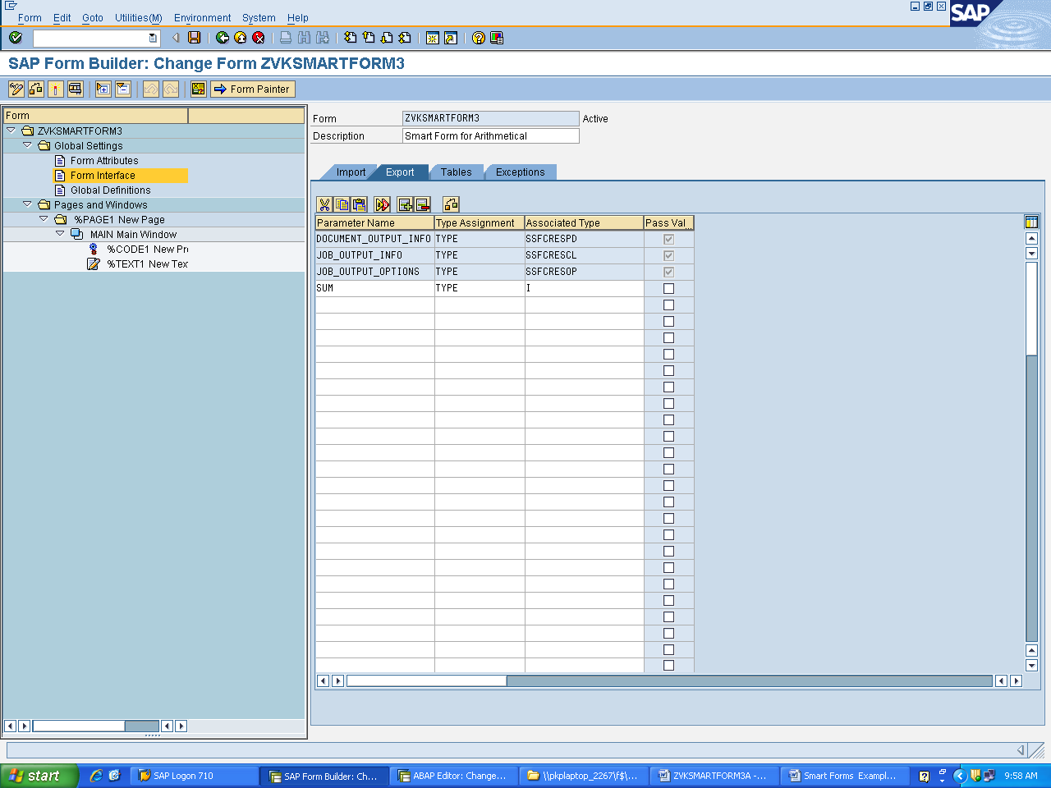

Variables which are declared in the form interface as import or export parameters need not have global definitions as they will be passed from the calling program written in editor.